Redcliffe Gift

bd00017_ runner

At Redcliffe Harness Racing Club

Cnr Oxley Drive& Gomersall Street

Redcliffe QLD

The Gift will be run on a granite surface track so make sure you wear short spikes

Wednesday Night 26th May 2021

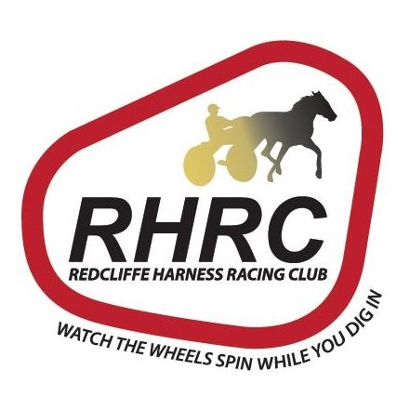

## EVENT ENTRY FEE PRIZE

## QAL members non QAL members Approx Start Time

### *110m Open Gift Open Limit $30 $35 $10000 6pm*

### *Sponsored by Redcliffe Harness Racing Club*

### *ENTRIES CLOSE 17TH May 2021*

### *NOMINATION*

***I wish to nominate for the following events: ( Tick where appropriate )***

***110 metres Gift ( )***

***Entry fee ( ) is enclosed . Cheques should be made payable to Queensland Professional Athletic League Inc and forwarded to Darren Kynaston 17 Benarkin Street Forest Lake 4078 or email*** [***kynastondarren@gmail.com***](mailto:kynastondarren@gmail.com)

***Online fees ( )***

***To enter online credit Qld Professional Athletic League Bank of Queensland BSB 124- 053 account 10196537 \*\*\*YOU MUST INCLUDE YOUR NAME ON THE DEPOSIT SLIP\*\*\****

***Covid-19 for health reasons competing athletes are required to wear a singlet, not a T/Shirt, under a QAL allocated coloured bib.***